CAN Sensor System

This project is implanting a basic system for data communication using CAN communication protocol. This is done using an Arduino Uno development board, a HC-SR04 ultrasonar sensor and 2 MCP2515 CAN communication modules.

The ultrasonar sensor measures distance and sends that data to the Arduino and the microcontroller through the SPI communication protocol. That data is sent to one of the CAN modules through SPI communication. And then the data is sent to the other CAN module through CAN communication. The other module sends data to Arduino for display.

The data is sent to Raspberry Pi 3 which has the role of server that stores the database. Then using Flask that data is displayed on a HTML site.

Figure 1: Functional diagram of distance sensor project

As per the data link layer, communication over the CAN bus is done via CAN frames.

Below is a standard CAN data frame with 11 bits identifier (CAN 2.0A), which is the type used in most cars. The extended 29-bit identifier frame (CAN 2.0B) is identical except the longer ID. It is e.g. used in the [J1939 protocol](https://www.csselectronics.com/pages/j1939-explained-simple-intro-tutorial) for heavy-duty vehicles.

Note that the CAN ID and Data are highlighted - these are important when recording CAN bus data, as we will see below

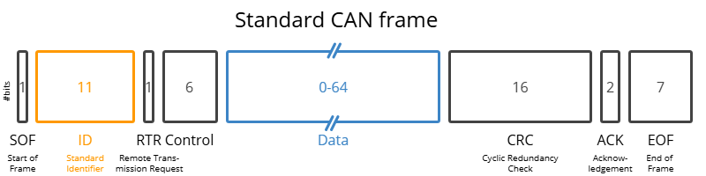

* **SOF:**The Start of Frame is a 'dominant 0' to tell the other nodes that a CAN node intends to talk
* **ID:**The ID is the frame identifier - lower values have higher priority
* **RTR:** The Remote Transmission Request indicates whether a node sends data or requests dedicated data from another node
* **Control:**The Control contains the Identifier Extension Bit (IDE) which is a 'dominant 0' for 11-bit. It also contains the 4 bit Data Length Code (DLC) that specifies the length of the data bytes to be transmitted (0 to 8 bytes)
* **Data:** The Data contains the data bytes aka payload, which includes CAN signals that can be decoded for information
* **CRC:**The Cyclic Redundancy Check is used to ensure data integrity
* **ACK:**The ACK slot indicates if the node has acknowledged and received the data correctly
* **EOF:** The EOF marks the end of the CAN frame

The circuit with Arduino and MCP 2515 module transreceivers

Figure 1: CAN Communication system

The figure 1 shows the wiring of the CAN modules to the Arduino microcontroller.

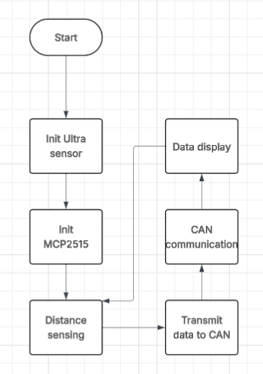

Figure 2 : Flowchart of CAN Sensor System

The next figures show the protocol built and the results.

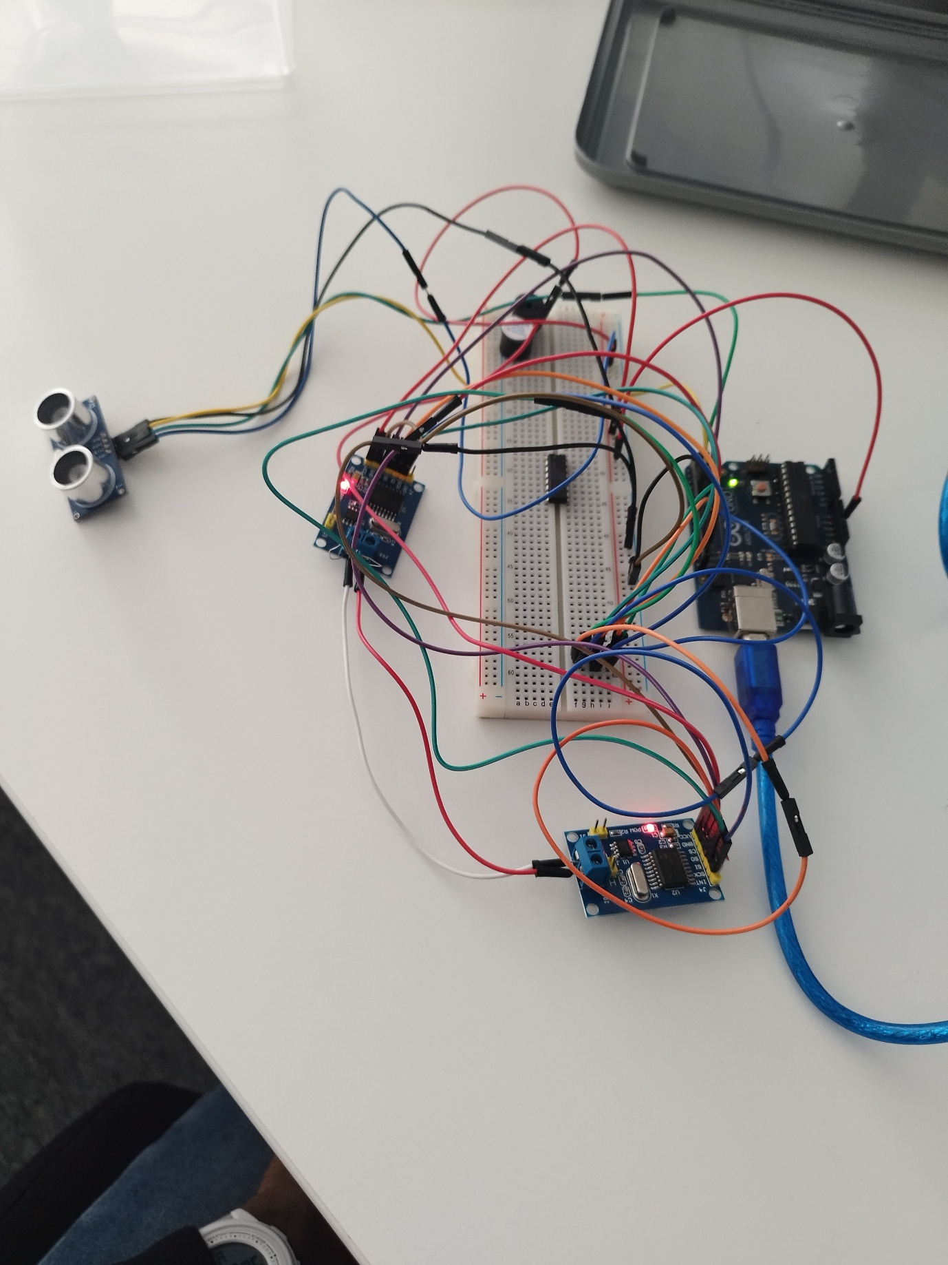

Figure 3 : Prototype of CAN Sensor System

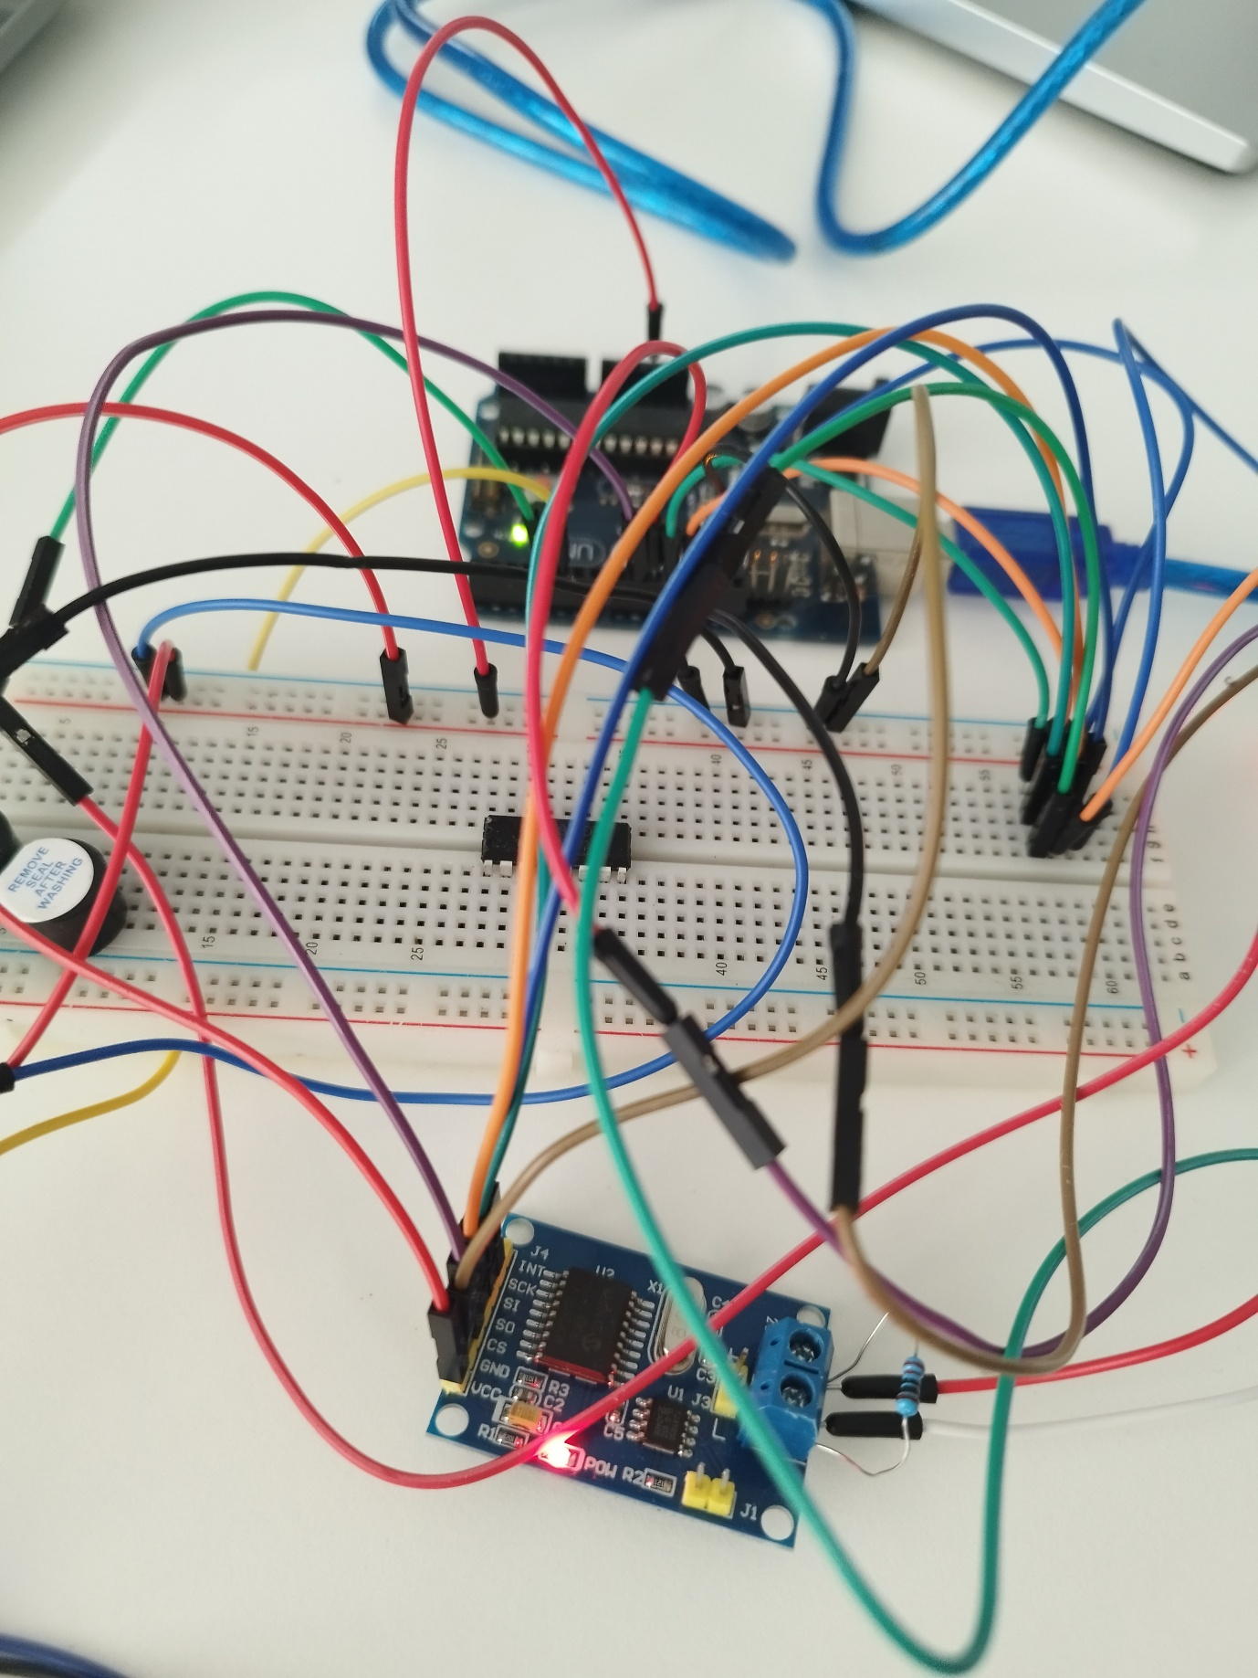

Figure 4 : MCP2515 module

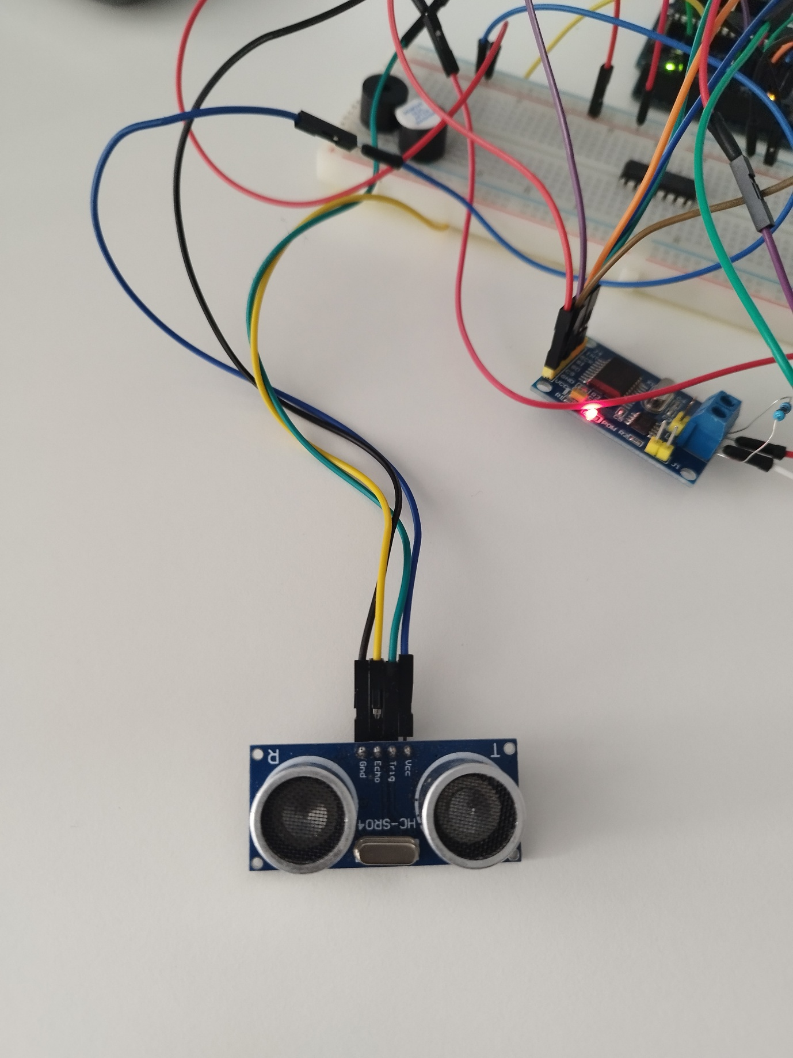

Figure 5 : HC-SR04 Sensor

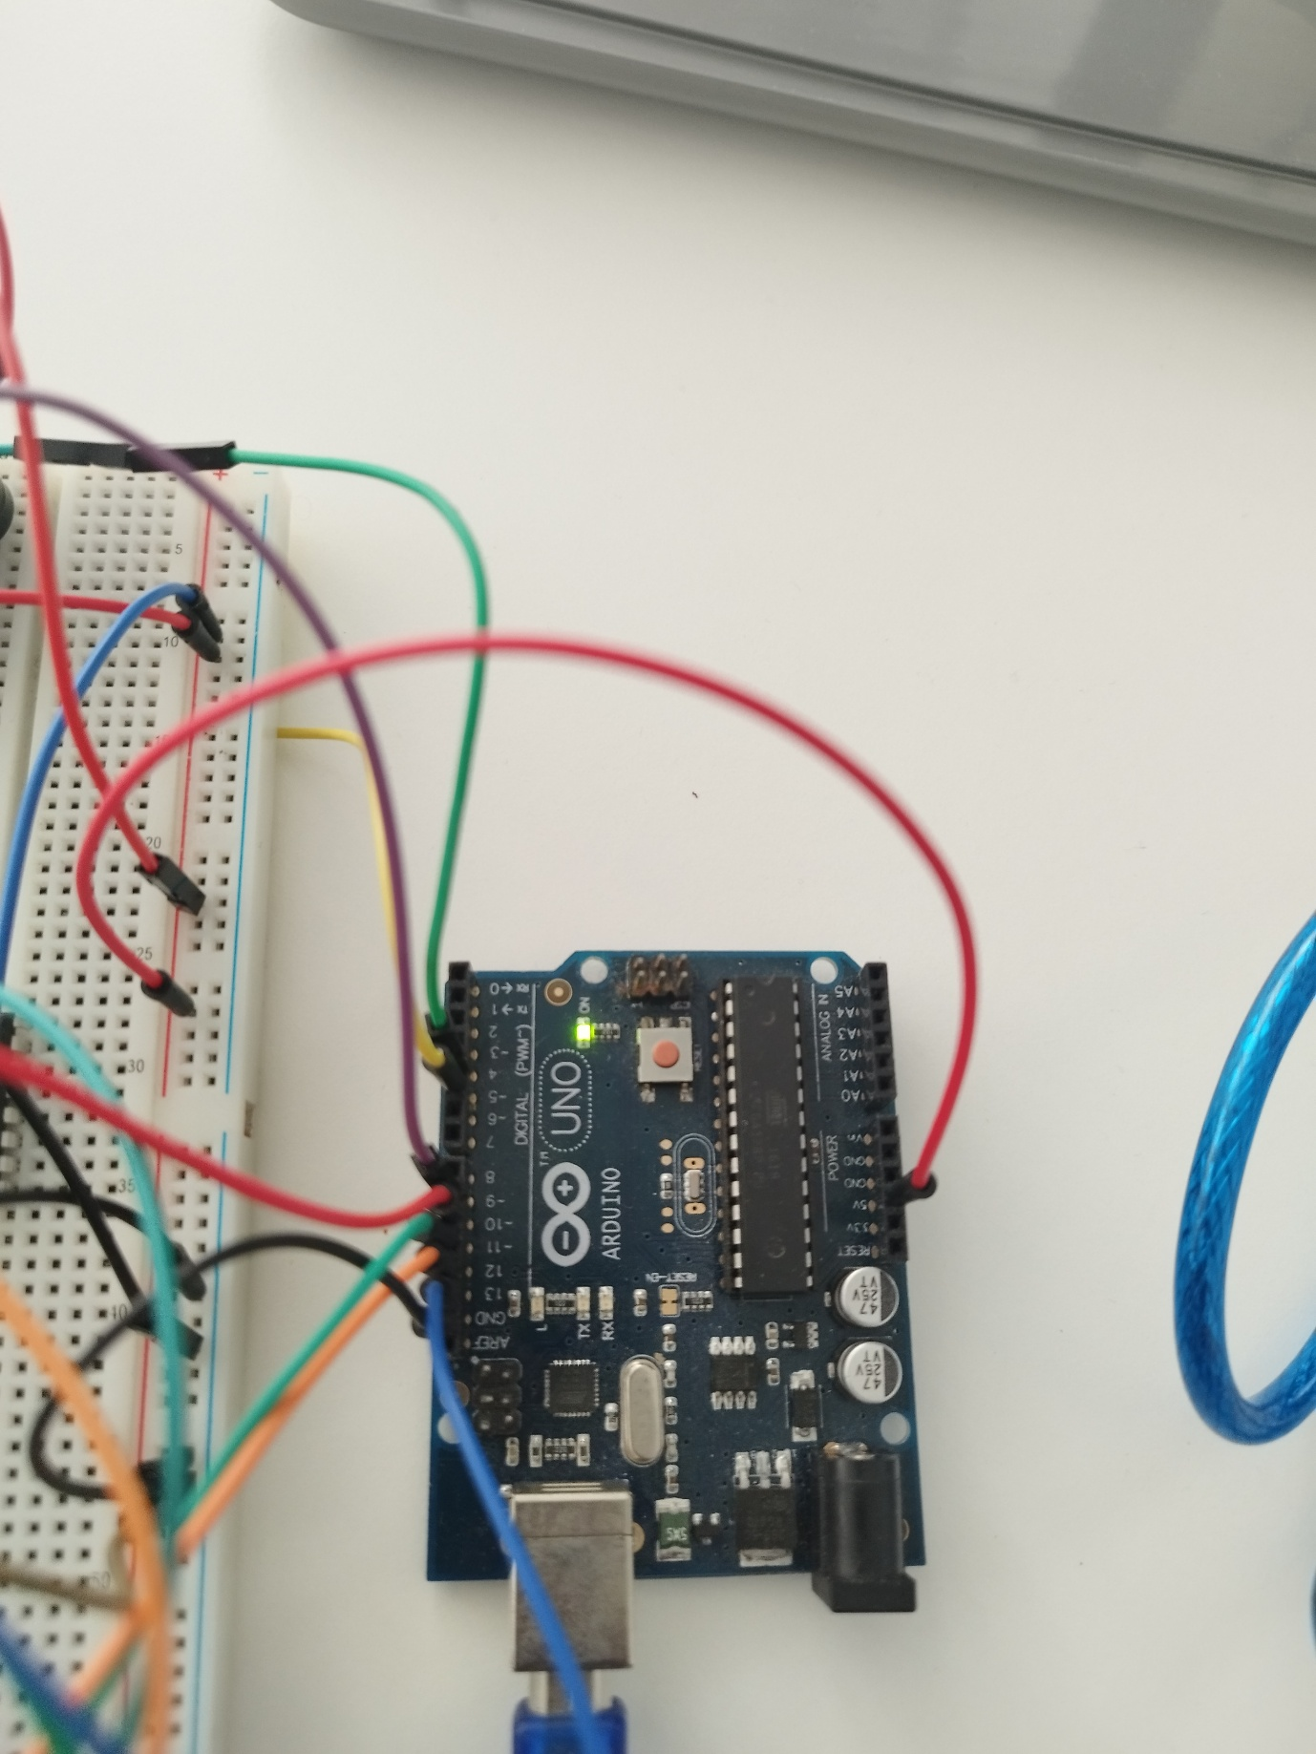

Figure 6 : Arduino development board

Figure 7 : Serial display of data

The code in the RaspberryPi was done on Visual Studio code. Using versioning I put the code in a git repository using my Github account.

The first thing I do is read the serial data from the Arduino board to the raspberrypi using a serial port. The data is converted to a database and stored in a directory with the whole project including the code.

In order to work on the code I would work on it on my PC using VS Code while committing the code and pulling it on the raspberry Pi directory where the project is situated.

When executed the code produces a database file.

So I prepared a simple HTML page with a table listing the data.

I downloaded the python pack to be able to use Flask to create a local site with the database and appearance of the HTML file created previously.

